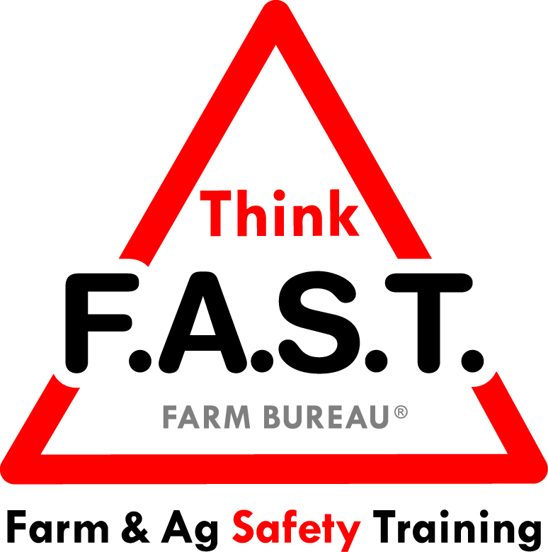

Module 4: Task Breakdown and Job Safety Analysis with Personal Protective Equipment (PPE)

Objectives:
- The learner will understand that breaking down a task is crucial for the safety and successful completion of that task.
- The learner will demonstrate knowledge of appropriate Personal Protective Equipment (PPE).

Time Required:
- Approximately 40 minutes

Materials & Set-Up:
- Pens/paper/highlighter – per PPE station (5 total)
- Timer (watch, clock, or phone is appropriate)
- Variety of personal protective equipment, specific to common shop/farm tasks, as well as regionally-appropriate PPE. There must be at least one example of PPE in each of the following categories:
  - Hearing
  - Skin
  - Respiratory
  - Vision
  - Clothing/Dress

Lesson:

Introduction
- To engage youth, ask them to think about a task that they did prior to coming to the training that day. Have one participant share their example.
- As a group, ask them to break down the example task, step-by-step. Follow up with questions that prompt discussion, such as “What could happen if they didn’t do _______ step?”
- Remind them that thinking about the steps involved in a task is critical to safely and successfully completing a task. Some routine, simple tasks – like making a sandwich – may not require as much thought as more complex tasks, like changing a car tire.
- Preview that today’s focus is on personal protective equipment, or PPE. Being able to breakdown a task and assess whether PPE is necessary is critical for safety and success.

Suggested Skill Building Activities:
*Note: Instructor may modify for time and regionally-appropriate content, as long as safety and core skills are adequately addressed.

- “What would happen if…” Task Breakdown
  - Engage the group to respond to the following “what if” task-specific questions (modify as appropriate for the group or region):
    - What if…you forgot jelly on your PB&J?
    - What if…you didn’t set the brake when you were changing a flat tire?
    - What if…you forgot to shut the gate after checking cattle in the pasture, which is directly beside a major highway?
    - What if…you didn’t turn the water back on after cleaning out the water troughs?
    - What if…you didn’t turn off the blades on the mower before getting off to clear a stick from the discharge?

Core skill: We have to be able to break down a task and complete each step, for our safety and the safety of those around us.
Indicators of activity success:
- Through active participation, learners are engaged in thoughtful responses to the task breakdown activity.

- Personal Protective Equipment (PPE)
  - If possible, have PPE broken down into different stations/areas, according to the following categories: Hearing, Skin, Respiratory, Vision, and Clothing/Dress. At each station have examples of specific PPE in that category as well as a piece of paper, a pen, and a highlighter.
  - Break the class into 5 groups, one per PPE station. Have the groups fold the paper in half, and write the following descriptors on each half of the page:
Dangers of not using this PPE
More examples of PPE in this category

  - Set a timer for 1 minute, and have each group collaborate to write down their responses at their station. When the timer goes off, the groups rotate and complete the activity at the next station. Continue until all the groups have visited all five stations.
  - After their final station, have the groups stay in place and use the highlighter to choose their top item in each category. Groups will share out their top choices of example of PPE and danger of not using this PPE.

Core skill: Understanding that PPE is a valuable part of safely completing tasks.
Indicators of activity success:
- Through active participation, learners demonstrate knowledge or desire to learn about personal protective equipment.

Reflection Questions
- To close out the lesson, ask youth the following questions, and allow for individual or group discussion:
  - What is one category of PPE (hearing, skin, respiratory, vision, clothing/dress) that you need to increase your use? What will you do to make this change?
  - How can you be more proactive in your use of PPE?

Challenge
- 1 in 5 American swill develop skin cancer over the course of their lifetime⁽¹⁾. Look around the group – how many would that be? The simple act of putting on sunscreen and wearing an appropriate hat everyday can be your first step to reducing your chance of this deadly disease. How will you use this PPE and others to protect yourself?

- Robinson, JK. Sun exposure, sun protection, and vitamin D. JAMA 2005; 294:1541-43.

