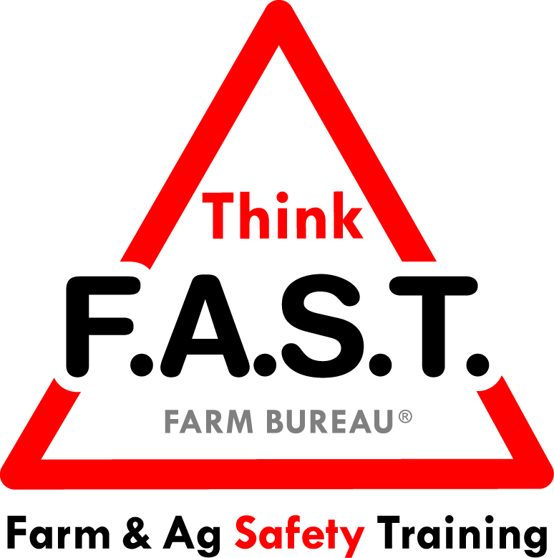

Module 1: Attention & Distractions with ATV’s and Utility Vehicles

Objectives:
- The learner will understand how attention and distractors play a role in safety, specific to an agricultural environment.
- The learner will demonstrate ATV/UTV safety training and best practices.

Time Required:
- Approximately 40 minutes

Materials & Set-Up:
- Pens/paper – per individual
- ATV or utility vehicle
- Cell phone
- Ear buds / headphones
- Personal protective equipment appropriate for ATV or utility vehicle use
  - Mandatory: Helmet
  - Optional: Goggles, gloves, etc.

Lesson:

Introduction
- To engage youth, ask them what they remember seeing on their travel to the training today. It might sound like “How many of you remember the ride here today? What did you remember seeing along the road?”
- After a few responses, ask them if they were doing something else that was taking their attention away from watching the road.
- Remind them of how easy it is to get distracted and why we have to work at attending to what’s around us – especially on the farm.
- Preview that today’s focus is on ATVs and utility vehicles and the importance of safe operation. Note that attention and avoiding distractions are always important on the farm, but are especially important when operating these vehicles.

Suggested Skill Building Activities:
*Note: Instructor may modify for time and regionally-appropriate content, as long as safety and core skills are adequately addressed.

- Distractors!
  - Remind youth about 4 common areas that contribute to distractions:
    - Technology
    - Other people
    - Personal thoughts
    - Time
  - Ask them to write the 4 categories on their paper, and put a check beside the one(s) they struggle with the most. For each one they have checked, have them write their biggest challenge, and their solution to this challenge and distractor.
  - Have learners pair up or work in small groups to share their challenges with distractions and solutions. Allow small groups to discuss as interest and attention allows.
  - If time allows, open up for group discussion and input.

Core skill: We have to consciously limit distractions for a productive and safe work environment.
Indicators of activity success:
- Through active participation, learners are engaged and honest about their challenges and solutions for limiting distractions.

- Before you Ride
  - Have youth come around the ATV/UTV. Present and discuss the following items: (Questions in italics are starting points for relevant discussion.)
    - Pre-ride visual assessment of the vehicle
What are you looking for on this ATV/UTV? What would you do if you saw something out of place or damaged?
    - Age-appropriate ability
How do you know if an ATV/UTV is appropriate for you? What are some things you will assess?
    - Personal protective equipment (PPE) and Safe Riding
What safety equipment should always be available and in working condition? What could happen if you don’t use it? How should you position yourself on an ATV or UTV for the safest ride?

Core skill: Assessing equipment and PPE availability prior to using an ATV/UTV is a crucial part of successful use.
Indicators of activity success:
- Through active participation, learners are engaged in pre-ride activity.
- Learners indicate working knowledge or desire to learn components of setting up a safe ride on an ATV/UTV.

- A Safe Ride
  - Break class into four groups. Give each group one of the following scenarios. Tell youth that they will work in their groups to present their scenario & solution to the rest of the class in skit form. Give youth a few minutes to collaborate, then allow for presentations and feedback.
    - Scenario 1: You’re riding on the ATV and your phone notifications keep tempting you to look at your phone. What should you do?
    - Scenario 2: You love the music you just downloaded to your phone, and think that listening to it while you’re bringing in the cows should be ok, especially since you have ear buds. What should you do?
    - Scenario 3: You have to take the UTV (which has 2 seatbelts) down to the barn. Your sister and her friend both want to ride with you. What should you do?
    - Scenario 4: You were up incredibly late last night studying for the test, and your 4 a.m. wake up call to get to the dairy is really hard this morning! You get on the ATV to go to the barn & can’t find your helmet when you glance around. What should you do?

Core skill: Safety during operation of an ATV/UTV is a critical part of successful use.
Indicators of activity success:
- Through active participation, learners are engaged in scenarios and discussion of safety while operating an ATV/UTV
- Learners indicate working knowledge or desire to learn components of safe operation for an ATV/UTV.

Reflection Questions
- To close out the lesson, ask youth the following questions, and allow for individual or group discussion:
  - What is one thing you are going to do to decrease distractions while in a farm or ranch environment?
  - Is there anything you need to do to be more proactive for your safety around an ATV/UTV? If so, what? And how are you going to implement this change?

Challenge
- The very next time you prepare to use an ATV or UTV, go behind it and attempt to lift the back off the ground. Use that to remind yourself how much injury you’d likely suffer if it rolled on top of you because you got distracted.

Additional Resources:
- U.S. Consumer Product Safety Commission:
  - ATV injury statistics infographic: http://onsafety.cpsc.gov/blog/2014/05/22/cpsc-infographic-big-real-rough-tough-deadly-atv-statistics/
  - State-specific statistics: http://www.cpsc.gov/en/Safety-Education/Safety-Education-Centers/ATV-Safety-Information-Center/Death-Associated-With-ATVs-by-State-/
- Optional reflection questions:
  - Is your state in the top 10 for ATV injuries? If so, what factors do you think contribute to that?
  - If your state is not in the top 10, why do you think some states have such high rates of death and injury with ATV’s?
  - How do you think attention and distractions may play into these rates?

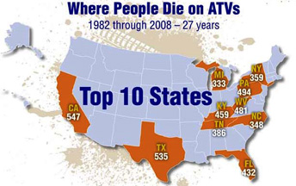
Source: http://www.cpsc.gov/en/Safety-Education/Safety-Education-Centers/ATV-Safety-Information-Center/

